Pre-Search Pattern Two

* **a name for the pattern: Related Search Requests**
* **a wireframe picture** 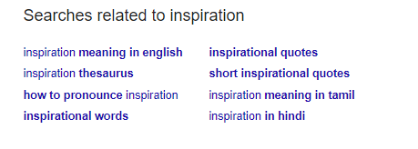
* **use when**

1. Use when the search request is too general
2. Use when the user is doing research
3. Use when the user may be interested in something specific

* **how** (describes how the pattern may be applied)

The idea is to display some search related options. These might be the options other users were looking for, or just some random options related to user’s search request. This pattern may help user to search for more specific information or help with research in a specific domain.

* **a discussion of** how you have applied this pattern in your own information seeking.

When I have little knowledge of a specific domain, I am usually using this pattern to search for information. It helps a lot, because it provides many different search options that are somehow related to my search term. Thus, I can carry a deep research and look at the subject of my interest from many different angles.

In case of application I am going to develop, this pattern will be used in the following way. For example, the user is looking for volunteering events in his/her town. The app is going to suggest events from other cities, as well as events that are related to volunteering and popular events among people which are usually taking part in volunteering events.